Coronavirus disease 2019 (COVID-19)
Situation Report – 94

Data as received by WHO from national authorities by 10:00 CEST, 23 April 2020

HIGHLIGHTS

- The Global Outbreak Alert and Response Network (GOARN) has launched a GOARN COVID-19 Knowledge hub. The hub is designed as a central repository of quality public health information, guidance, tools and webinars which can be accessed freely at any point.

- WHO Director-General Dr. Tedros, in his regular media briefing yesterday, cautioned that “we have a long way to go. This virus will be with us for a long time”. He added that “the world cannot go back to the way things were. There must be a “new normal” – a world that is healthier, safer and better prepared”. His speech can be found here.

- WHO has published guidance ‘Addressing Human Rights as Key to the COVID-19
Respo nse’ . The guidance document highlights the importance of integrating a human rights-based approach into the COVID-19 response and highlights key considerations in relation to addressing stigma and discrimination, prevention of violence against women, support for vulnerable populations, quarantine and restrictive measures, and shortages of supplies and equipment.

- All available evidence for COVID-19 suggests that SARS-CoV-2 has a zoonotic source. Many researchers have been able to look at the genomic features of SARS-CoV-2 and have found that evidence does not support that SARS-CoV-2 is a laboratory construct. A constructed virus would show a mix of known elements within genomic sequences – this is not the case. For more details, please see ‘subject in focus’.
SITUATION IN NUMBERS
total (new cases in last 24 hours)

Globally
2 544 792 confirmed (73 657)
175 694 deaths (6689)

European Region
1 251 458 confirmed (31 972)
113 336 deaths (3384)

Region of the Americas
957 402 confirmed (32 111)
47 812 deaths (3038)

Eastern Mediterranean Region
144 450 confirmed (5101)
6469 deaths (143)

Western Pacific Region
137 902 confirmed (1632)
5818 deaths (25)

South-East Asia Region
36 039 confirmed (2127)
1498 deaths (71)

African Region
16 829 confirmed (714)
748 deaths (28)

WHO RISK ASSESSMENT
Global Level Very High

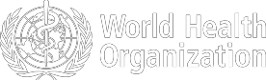
Figure 1. Countries, territories or areas with reported confirmed cases of COVID-19, 23 April 2020
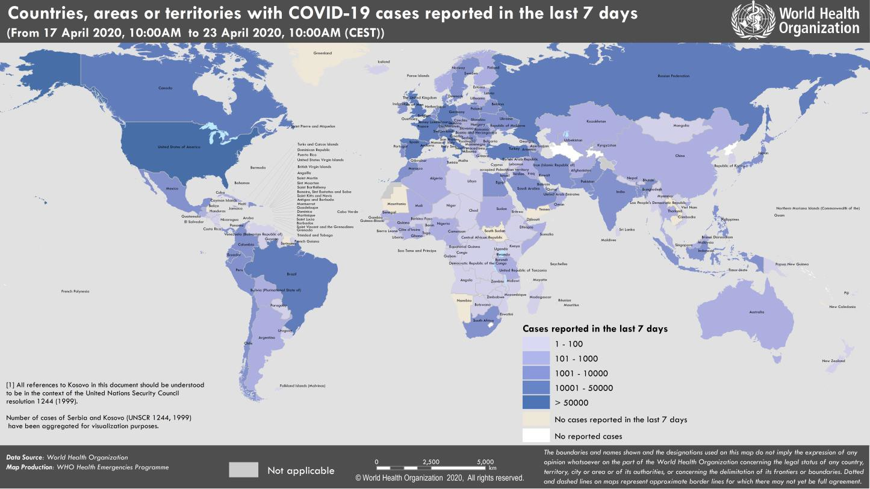

SUBJECT IN FOCUS: Origin of the severe acute respiratory syndrome coronavirus-2 (SARS-CoV-2), the virus causing COVID-19

The first human cases of COVID-19, the disease caused by the novel coronavirus causing COVID-19, subsequently named SARS-CoV-2 were first reported by officials in Wuhan City, China, in December 2019. Retrospective investigations by Chinese authorities have identified human cases with onset of symptoms in early December 2019. While some of the earliest known cases had a link to a wholesale food market in Wuhan, some did not. Many of the initial patients were either stall owners, market employees, or regular visitors to this market. Environmental samples taken from this market in December 2019 tested positive for SARS-CoV-2, further suggesting that the market in Wuhan City was the source of this outbreak or played a role in the initial amplification of the outbreak. The market was closed on 1 January 2020.

SARS-CoV-2 was identified in early January and its genetic sequence shared publicly on 11-12 January. The full genetic sequence of SARS-CoV-2 from the early human cases and the sequences of many other virus isolated from human cases from China and all over the world since then show that SARS-CoV-2 has an ecological origin in bat populations. All available evidence to date suggests that the virus has a natural animal origin and is not a manipulated or constructed virus. Many researchers have been able to look at the genomic features of SARS-CoV-2 and have found that evidence does not support that SARS-CoV-2 is a laboratory construct. If it were a constructed virus, its genomic sequence would show a mix of known elements. This is not the case.

Another coronavirus, SARS-CoV-1, the cause of the Severe Acute Respiratory Syndrome (SARS) outbreak in 2003, was also closely related to other coronaviruses isolated from bats. These close genetic relations of SARS-CoV-1, SARS- CoV-2 and other coronaviruses, suggest that they all have their ecological origin in bat populations. Many of these coronaviruses can also infect several animal species. For example, SARS-CoV-1 infected civet cats and then humans, while the virus causing the Middle East Respiratory Syndrome (MERS-CoV) is found in dromedary camels, and has continued to infect humans since 2012.

All available evidence for COVID-19 suggests that SARS-CoV-2 has a zoonotic source. Since there is usually limited close contact between humans and bats, it is more likely that transmission of the virus to humans happened through another animal species, one that is more likely to be handled by humans. This intermediate animal host or zoonotic source could be a domestic animal, a wild animal, or a domesticated wild animal and, as of yet, has not been identified.

All the published genetic sequences of SARS-CoV-2 isolated from human cases are very similar. This suggests that the start of the outbreak resulted from a single point introduction in the human population around the time that the virus was first reported in humans in Wuhan, China in December 2019.

A number of investigations to better understand the source of the outbreak in China are currently underway or planned, including investigations of human cases with symptom onset in and around Wuhan in late 2019, environmental sampling from markets and farms in areas where the first human cases were identified, and detailed records on the source and type of wildlife species and farmed animals sold in these markets.

Results from these studies are essential to preventing further zoonotic introductions of SARS-CoV-2 into the human population. WHO continues to collaborate with animal health and human health experts, Member States, and other partners to identify gaps and research priorities for the control of COVID-19, including the eventual identification of the source of the virus in China.
SURVEILLANCE

Table 1. Countries, territories or areas with reported laboratory-confirmed COVID-19 cases and deaths. Data as of 23 April 2020*

Reporting Country/ Territory/Area† | Total confirmed  ‡ cases |  | Total confirmed new cases | Total deaths | Total new deaths | Transmission classification§ | Days since last reported case
Western Pacific Region
China |  | 84302 | 15 | 4642 | 0 | Clusters of cases | 0
Japan |  | 11919 | 423 | 287 | 10 | Clusters of cases | 0
Republic of Korea |  | 10702 | 8 | 240 | 2 | Clusters of cases | 0
Singapore |  | 10141 | 1016 | 12 | 1 | Clusters of cases | 0
Philippines |  | 6710 | 111 | 446 | 9 | Clusters of cases | 0
Australia |  | 6654 | 7 | 74 | 0 | Clusters of cases | 0
Malaysia |  | 5532 | 50 | 93 | 1 | Clusters of cases | 0
New Zealand |  | 1112 | 0 | 16 | 2 | Clusters of cases | 1
Viet Nam |  | 268 | 0 | 0 | 0 | Clusters of cases | 6
Brunei Darussalam |  | 138 | 0 | 1 | 0 | Sporadic cases | 3
Cambodia |  | 122 | 0 | 0 | 0 | Sporadic cases | 11
Mongolia |  | 35 | 1 | 0 | 0 | Sporadic cases | 0
Lao People's Democratic Republic |  | 19 | 0 | 0 | 0 | Sporadic cases | 10
Fiji |  | 18 | 0 | 0 | 0 | Sporadic cases | 2
Papua New Guinea |  | 8 | 1 | 0 | 0 | Sporadic cases | 0
Territories**
Guam |  | 133 | 0 | 5 | 0 | Clusters of cases | 11
French Polynesia |  | 57 | 0 | 0 | 0 | Sporadic cases | 1
New Caledonia |  | 18 | 0 | 0 | 0 | Sporadic cases | 20
Northern Mariana Islands (Commonwealth of the) |  | 14 | 0 | 2 | 0 | Pending | 5
European Region
Spain |  | 208389 | 4211 | 21717 | 435 | Pending | 0
Italy |  | 187327 | 3370 | 25085 | 437 | Community transmission | 0
Germany |  | 148046 | 2352 | 5094 | 215 | Community transmission | 0
The United Kingdom |  | 133499 | 4451 | 18100 | 763 | Community transmission | 0
France |  | 117961 | 1810 | 21307 | 544 | Community transmission | 0
Turkey |  | 98674 | 3083 | 2376 | 117 | Community transmission | 0
Russian Federation |  | 62773 | 4774 | 555 | 42 | Clusters of cases | 0
Belgium |  | 41889 | 933 | 6262 | 264 | Community transmission | 0

Netherlands | 34842 | 708 | 4054 | 138 | Community transmission | 0
Switzerland | 28186 | 205 | 1216 | 30 | Community transmission | 0
Portugal | 21982 | 603 | 785 | 23 | Pending | 0
Ireland | 16671 | 631 | 769 | 39 | Pending | 0
Sweden | 16004 | 682 | 1937 | 172 | Pending | 0
Austria | 14924 | 91 | 494 | 31 | Pending | 0
Israel | 14498 | 556 | 189 | 5 | Pending | 0
Poland | 10169 | 313 | 426 | 25 | Pending | 0
Romania | 9710 | 468 | 508 | 25 | Community transmission | 0
Denmark | 7912 | 217 | 384 | 14 | Pending | 0
Belarus | 7281 | 558 | 60 | 5 | Community transmission | 0
Norway | 7250 | 84 | 169 | 6 | Pending | 0
Ukraine | 7170 | 578 | 187 | 13 | Community transmission | 0
Czechia | 7136 | 95 | 210 | 9 | Community transmission | 0
Serbia | 7114 | 224 | 134 | 4 | Pending | 0
Finland | 4129 | 115 | 149 | 8 | Pending | 0
Luxembourg | 3654 | 36 | 80 | 2 | Pending | 0
Republic of Moldova | 2778 | 137 | 76 | 3 | Pending | 0
Greece | 2408 | 7 | 121 | 0 | Pending | 0
Hungary | 2284 | 116 | 225 | 0 | Clusters of cases | 0
Kazakhstan | 2025 | 30 | 19 | 0 | Pending | 0
Croatia | 1950 | 42 | 48 | 0 | Pending | 0
Iceland | 1785 | 7 | 10 | 0 | Community transmission | 0
Uzbekistan | 1716 | 59 | 7 | 1 | Clusters of cases | 0
Estonia | 1559 | 7 | 44 | 1 | Pending | 0
Azerbaijan | 1518 | 38 | 20 | 0 | Clusters of cases | 0
Armenia | 1473 | 96 | 24 | 0 | Clusters of cases | 0
Lithuania | 1398 | 28 | 38 | 0 | Pending | 0
Bosnia and Herzegovina | 1367 | 27 | 52 | 2 | Community transmission | 0
Slovenia | 1353 | 13 | 79 | 2 | Community transmission | 0
North Macedonia | 1259 | 28 | 56 | 1 | Clusters of cases | 0
Slovakia | 1244 | 45 | 14 | 0 | Clusters of cases | 0
Bulgaria | 1024 | 49 | 49 | 4 | Pending | 0
Cyprus | 790 | 6 | 17 | 0 | Clusters of cases | 0
Latvia | 761 | 13 | 11 | 2 | Pending | 0
Andorra | 724 | 1 | 37 | 0 | Community transmission | 0
Albania | 634 | 0 | 27 | 1 | Clusters of cases | 1
Kyrgyzstan | 631 | 19 | 8 | 1 | Pending | 0
San Marino | 488 | 12 | 40 | 0 | Community transmission | 0
Malta | 444 | 1 | 3 | 0 | Pending | 0

Georgia | 420 | 9 | 5 | 0 | Community transmission | 0
Montenegro | 314 | 1 | 5 | 0 | Clusters of cases | 0
Liechtenstein | 82 | 0 | 1 | 0 | Pending | 4
Monaco | 68 | 0 | 1 | 0 | Sporadic cases | 9
Holy See | 9 | 0 | 0 | 0 | Sporadic cases | 2
Territories**
Kosovo[1] | 630 | 26 | 18 | 0 | Community transmission | 0
Isle of Man | 307 | 0 | 10 | 0 | Pending | 1
Jersey | 255 | 5 | 14 | 0 | Pending | 0
Guernsey | 241 | 2 | 10 | 0 | Community transmission | 0
Faroe Islands | 185 | 0 | 0 | 0 | Pending | 3
Gibraltar | 133 | 0 | 0 | 0 | Clusters of cases | 5
Greenland | 11 | 0 | 0 | 0 | Pending | 17
South-East Asia Region
India | 21393 | 1409 | 681 | 41 | Clusters of cases | 0
Indonesia | 7418 | 283 | 635 | 19 | Community transmission | 0
Bangladesh | 3772 | 390 | 120 | 10 | Pending | 0
Thailand | 2839 | 13 | 50 | 1 | Pending | 0
Sri Lanka | 330 | 20 | 7 | 0 | Clusters of cases | 0
Myanmar | 127 | 6 | 5 | 0 | Clusters of cases | 0
Maldives | 85 | 2 | 0 | 0 | Clusters of cases | 0
Nepal | 45 | 3 | 0 | 0 | Sporadic cases | 0
Timor-Leste | 23 | 0 | 0 | 0 | Clusters of cases | 2
Bhutan | 7 | 1 | 0 | 0 | Sporadic cases | 0
Eastern Mediterranean Region
Iran (Islamic Republic of) | 85996 | 1194 | 5391 | 94 | Community transmission | 0
Saudi Arabia | 12772 | 1141 | 114 | 5 | Clusters of cases | 0
Pakistan | 10513 | 764 | 224 | 15 | Clusters of cases | 0
United Arab Emirates | 8238 | 483 | 52 | 6 | Pending | 0
Qatar | 7141 | 608 | 10 | 1 | Pending | 0
Egypt | 3659 | 169 | 276 | 12 | Clusters of cases | 0
Morocco | 3446 | 237 | 149 | 4 | Clusters of cases | 0
Kuwait | 2248 | 168 | 13 | 2 | Clusters of cases | 0
Bahrain | 2027 | 54 | 7 | 0 | Clusters of cases | 0
Oman | 1716 | 102 | 8 | 0 | Clusters of cases | 0
Iraq | 1631 | 29 | 83 | 0 | Clusters of cases | 0
Afghanistan | 1176 | 84 | 40 | 4 | Clusters of cases | 0
Djibouti | 974 | 29 | 2 | 0 | Clusters of cases | 0
Tunisia | 909 | 8 | 38 | 0 | Community transmission | 0
Lebanon | 682 | 0 | 22 | 0 | Clusters of cases | 1
Jordan | 435 | 7 | 7 | 0 | Clusters of cases | 0
Somalia | 286 | 0 | 14 | 0 | Sporadic cases | 1
Sudan | 162 | 22 | 13 | 0 | Sporadic cases | 0
Libya | 60 | 1 | 1 | 0 | Clusters of cases | 0

Syrian Arab Republic | 42 | 0 | 3 | 0 | Community transmission | 1
Yemen | 1 | 0 | 0 | 0 | Pending | 12
Territories**
occupied Palestinian territory | 336 | 1 | 2 | 0 | Clusters of cases | 0
Region of the Americas
United States of America | 800926 | 24019 | 40073 | 2471 | Community transmission | 0
Brazil | 43079 | 2498 | 2741 | 166 | Community transmission | 0
Canada | 38923 | 1549 | 1871 | 143 | Community transmission | 0
Peru | 17837 | 1512 | 484 | 39 | Community transmission | 0
Chile | 11296 | 464 | 160 | 13 | Community transmission | 0
Ecuador | 10850 | 452 | 537 | 17 | Community transmission | 0
Mexico | 9501 | 729 | 857 | 145 | Community transmission | 0
Dominican Republic | 5300 | 256 | 260 | 15 | Community transmission | 0
Panama | 4821 | 163 | 141 | 5 | Community transmission | 0
Colombia | 4149 | 172 | 196 | 7 | Community transmission | 0
Argentina | 3197 | 124 | 152 | 7 | Community transmission | 0
Cuba | 1189 | 52 | 40 | 2 | Clusters of cases | 0
Costa Rica | 669 | 7 | 6 | 0 | Clusters of cases | 0
Bolivia (Plurinational State of) | 609 | 11 | 37 | 3 | Clusters of cases | 0
Uruguay | 543 | 8 | 12 | 2 | Clusters of cases | 0
Honduras | 510 | 16 | 46 | 0 | Clusters of cases | 0
Guatemala | 316 | 22 | 8 | 0 | Clusters of cases | 0
Venezuela (Bolivarian Republic of) | 288 | 3 | 10 | 0 | Clusters of cases | 0
El Salvador | 237 | 12 | 7 | 0 | Clusters of cases | 0
Jamaica | 233 | 10 | 6 | 0 | Clusters of cases | 0
Paraguay | 213 | 5 | 9 | 1 | Community transmission | 0
Trinidad and Tobago | 115 | 1 | 8 | 0 | Sporadic cases | 0
Barbados | 75 | 0 | 5 | 0 | Clusters of cases | 6
Guyana | 67 | 1 | 7 | 0 | Clusters of cases | 0
Bahamas | 65 | 1 | 9 | 0 | Clusters of cases | 0
Haiti | 58 | 1 | 4 | 1 | Clusters of cases | 0
Antigua and Barbuda | 24 | 1 | 3 | 0 | Clusters of cases | 0
Belize | 18 | 0 | 2 | 0 | Sporadic cases | 8
Dominica | 16 | 0 | 0 | 0 | Clusters of cases | 12
Saint Kitts and Nevis | 15 | 0 | 0 | 0 | Sporadic cases | 2
Saint Lucia | 15 | 0 | 0 | 0 | Sporadic cases | 11
Grenada | 14 | 0 | 0 | 0 | Clusters of cases | 1

Saint Vincent and the Grenadines | 13 | 1 | 0 | 0 | Sporadic cases | 0
Nicaragua | 10 | 0 | 2 | 0 | Pending | 1
Suriname | 10 | 0 | 1 | 0 | Sporadic cases | 19
Territories**
Puerto Rico | 1298 | 0 | 64 | 0 | Clusters of cases | 1
Martinique | 164 | 1 | 14 | 0 | Clusters of cases | 0
Guadeloupe | 148 | 0 | 12 | 0 | Clusters of cases | 3
Aruba | 100 | 3 | 2 | 0 | Clusters of cases | 0
Bermuda | 98 | 12 | 5 | 0 | Clusters of cases | 0
French Guiana | 97 | 0 | 1 | 0 | Clusters of cases | 2
Sint Maarten | 71 | 3 | 11 | 1 | Clusters of cases | 0
Cayman Islands | 66 | 0 | 1 | 0 | Clusters of cases | 1
United States Virgin Islands | 54 | 0 | 3 | 0 | Clusters of cases | 1
Saint Martin | 38 | 1 | 2 | 0 | Sporadic cases | 0
Curaçao | 14 | 0 | 1 | 0 | Sporadic cases | 14
Falkland Islands (Malvinas) | 12 | 1 | 0 | 0 | Clusters of cases | 0
Montserrat | 11 | 0 | 0 | 0 | Sporadic cases | 9
Turks and Caicos Islands | 11 | 0 | 1 | 0 | Sporadic cases | 6
Saint Barthelemy | 6 | 0 | 0 | 0 | Sporadic cases | 23
Bonaire, Sint Eustatius and Saba | 5 | 0 | 0 | 0 | Sporadic cases | 5
British Virgin Islands | 4 | 0 | 1 | 0 | Sporadic cases | 3
Anguilla | 3 | 0 | 0 | 0 | Sporadic cases | 19
Saint Pierre and Miquelon | 1 | 0 | 0 | 0 | Sporadic cases | 15
African Region
South Africa | 3635 | 170 | 65 | 7 | Community transmission | 0
Algeria | 2910 | 99 | 402 | 10 | Community transmission | 0
Cameroon | 1163 | 0 | 43 | 0 | Clusters of cases | 2
Ghana | 1154 | 112 | 9 | 0 | Clusters of cases | 0
Côte d’Ivoire | 952 | 36 | 14 | 1 | Clusters of cases | 0
Guinea | 761 | 73 | 6 | 0 | Community transmission | 0
Niger | 662 | 5 | 22 | 2 | Clusters of cases | 0
Burkina Faso | 600 | 19 | 38 | 0 | Community transmission | 0
Nigeria | 541 | 0 | 19 | 0 | Community transmission | 3
Senegal | 442 | 30 | 6 | 1 | Clusters of cases | 0
Democratic Republic of the Congo | 359 | 0 | 25 | 0 | Clusters of cases | 1
Mauritius | 329 | 1 | 9 | 0 | Community transmission | 0
Kenya | 303 | 7 | 14 | 0 | Clusters of cases | 0
Mali | 293 | 35 | 17 | 3 | Clusters of cases | 0

United Republic of Tanzania | 285 | 30 | 10 | 0 | Clusters of cases | 0
Congo | 186 | 21 | 6 | 0 | Clusters of cases | 0
Gabon | 166 | 10 | 1 | 0 | Clusters of cases | 0
Rwanda | 153 | 3 | 0 | 0 | Clusters of cases | 0
Madagascar | 121 | 0 | 0 | 0 | Clusters of cases | 3
Ethiopia | 116 | 2 | 3 | 0 | Clusters of cases | 0
Liberia | 101 | 0 | 8 | 0 | Clusters of cases | 1
Togo | 88 | 2 | 6 | 0 | Clusters of cases | 0
Equatorial Guinea | 84 | 5 | 1 | 1 | Clusters of cases | 0
Zambia | 74 | 4 | 3 | 0 | Sporadic cases | 0
Cabo Verde | 67 | 0 | 1 | 0 | Sporadic cases | 1
Sierra Leone | 61 | 11 | 1 | 1 | Clusters of cases | 0
Uganda | 61 | 5 | 0 | 0 | Sporadic cases | 0
Benin | 54 | 0 | 1 | 0 | Sporadic cases | 2
Guinea-Bissau | 50 | 0 | 0 | 0 | Sporadic cases | 5
Mozambique | 41 | 2 | 0 | 0 | Sporadic cases | 0
Eritrea | 39 | 0 | 0 | 0 | Sporadic cases | 4
Chad | 34 | 0 | 0 | 0 | Sporadic cases | 1
Eswatini | 31 | 7 | 1 | 0 | Sporadic cases | 0
Zimbabwe | 28 | 0 | 4 | 1 | Sporadic cases | 1
Angola | 24 | 0 | 2 | 0 | Sporadic cases | 2
Malawi | 23 | 5 | 3 | 1 | Sporadic cases | 0
Botswana | 22 | 2 | 1 | 0 | Sporadic cases | 0
Namibia | 16 | 0 | 0 | 0 | Sporadic cases | 17
Central African Republic | 14 | 0 | 0 | 0 | Sporadic cases | 1
Burundi | 11 | 0 | 1 | 0 | Sporadic cases | 1
Seychelles | 11 | 0 | 0 | 0 | Sporadic cases | 16
Gambia | 10 | 0 | 1 | 0 | Sporadic cases | 2
Mauritania | 7 | 0 | 1 | 0 | Sporadic cases | 12
São Tomé and Príncipe | 7 | 3 | 0 | 0 | Sporadic cases | 0
South Sudan | 4 | 0 | 0 | 0 | Sporadic cases | 11
Territories**
Réunion | 410 | 0 | 0 | 0 | Clusters of cases | 1
Mayotte | 326 | 15 | 4 | 0 | Clusters of cases | 0
Subtotal for all Regions | 2544080 | 73657 | 175681 | 6689
International conveyance (Diamond Princess) | 712 | 0 | 13 | 0 | Not Applicable†† | 38
Grand total | 2544792 | 73657 | 175694 | 6689
*Numbers include both domestic and repatriated cases
†The designations employed and the presentation of the material in this publication do not imply the expression of any opinion whatsoever on the part of WHO concerning the legal status of any country, territory, city or area or of its authorities, or concerning the delimitation of its frontiers or boundaries. Dotted and dashed lines on maps represent approximate border lines for which there may not yet be full agreement.
‡Case classifications are based on WHO case definitions for COVID-19.
§Transmission classification is based on a process of country/territory/area self-reporting. Classifications are reviewed on a weekly basis and may be upgraded or downgraded as new information becomes available. Not all locations within a given country/territory/area are equally affected; countries/territories/areas experiencing multiple types of transmission are classified in the highest category reported. Within a given transmission category, different countries/territories/areas may have differing degrees of transmission as indicated by the differing numbers of cases, recency of cases, and other factors.
Terms:
- No cases: Countries/territories/areas with no confirmed cases (not shown in table)
- Sporadic cases: Countries/territories/areas with one or more cases, imported or locally detected
- Clusters of cases: Countries/territories/areas experiencing cases, clustered in time, geographic location and/or by common exposures
- Community transmission: Countries/area/territories experiencing larger outbreaks of local transmission defined through an assessment of factors including, but not limited to:
  - Large numbers of cases not linkable to transmission chains
  - Large numbers of cases from sentinel lab surveillance
  - Multiple unrelated clusters in several areas of the country/territory/area

** “Territories” include territories, areas, overseas dependencies and other jurisdictions of similar status
[1] All references to Kosovo should be understood to be in the context of the United Nations Security Council resolution 1244 (1999).
†† As the international conveyance (Diamond Princess) is no longer occupied, transmission classification cannot be applied.

Due to differences in reporting methods, retrospective data consolidation, and reporting delays, the number of new cases may not always reflect the exact difference between yesterday’s and today’s totals. WHO COVID-19 Situation Reports present official counts of confirmed COVID-19 cases, thus differences between WHO reports and other sources of COVID-19 data using different inclusion criteria and different data cutoff times are to be expected.

Figure 4. Epidemic curve of confirmed COVID-19, by date of report and WHO region through 23 April 2020

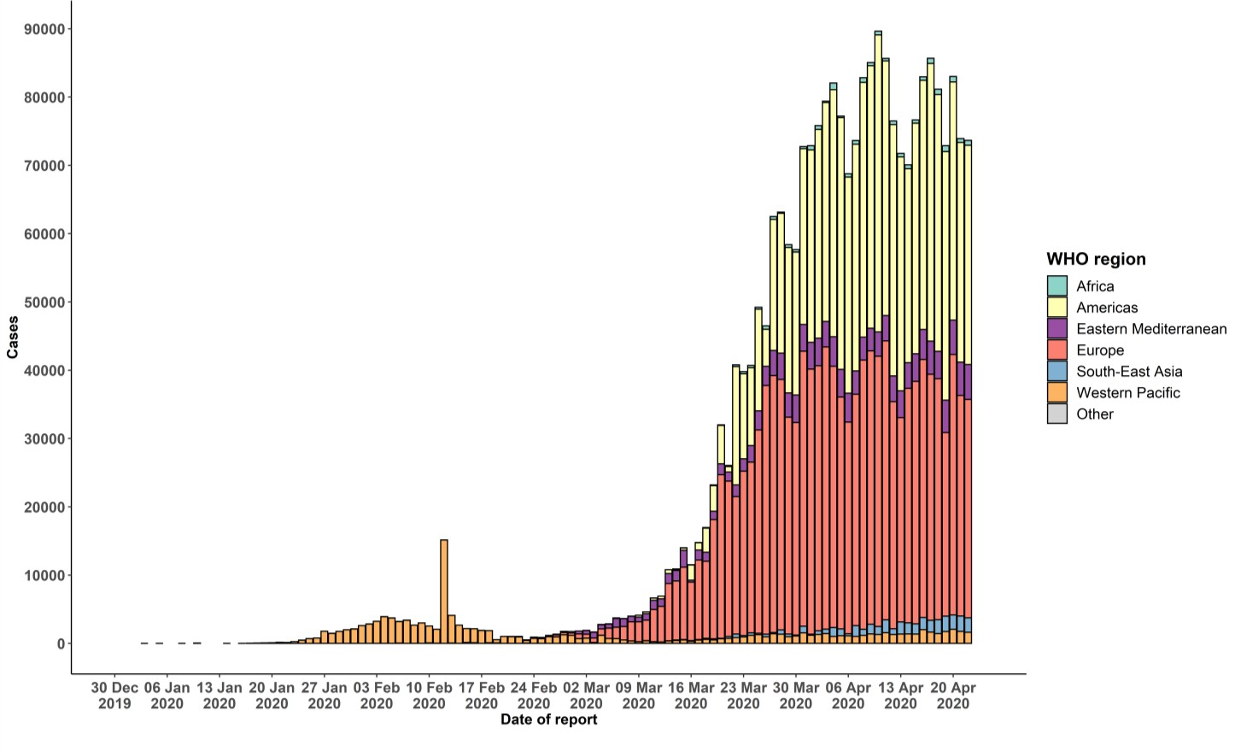
STRATEGIC OBJECTIVES

WHO’s strategic objectives for this response are to:

- Interrupt human-to-human transmission including reducing secondary infections among close contacts and health care workers, preventing transmission amplification events, and preventing further international spread*;
- Identify, isolate and care for patients early, including providing optimized care for infected patients;
- Identify and reduce transmission from the animal source;
- Address crucial unknowns regarding clinical severity, extent of transmission and infection, treatment options, and accelerate the development of diagnostics, therapeutics and vaccines;
- Communicate critical risk and event information to all communities and counter misinformation;
- Minimize social and economic impact through multisectoral partnerships.

*This can be achieved through a combination of public health measures, such as rapid identification, diagnosis and management of the cases, identification and follow up of the contacts, infection prevention and control in health care settings, implementation of health measures for travelers, awareness-raising in the population and risk communication.

PREPAREDNESS AND RESPONSE
- To view all technical guidance documents regarding COVID-19, please go to this webpage.
- WHO has developed interim guidance for laboratory diagnosis, advice on the use of masks during home care and in health care settings in the context of COVID-19 outbreak, clinical management, infection prevention and control in health care settings, home care for patients with suspected novel coronavirus, risk communication and community engagement and Global Surveillance for human infection with COVID-19.
- WHO is working closely with International Air Transport Association (IATA) and have jointly developed a guidance document to provide advice to cabin crew and airport workers, based on country queries. The guidance can be found on the IATA webpage.
- WHO has been in regular and direct contact with Member States where cases have been reported. WHO is also informing other countries about the situation and providing support as requested.
- WHO is working with its networks of researchers and other experts to coordinate global work on surveillance, epidemiology, mathematical modelling, diagnostics and virology, clinical care and treatment, infection prevention and control, and risk communication. WHO has issued interim guidance for countries, which are updated regularly.
- WHO has prepared a disease commodity package that includes an essential list of biomedical equipment, medicines and supplies necessary to care for patients with COVID-19.
- WHO has provided recommendations to reduce risk of transmission from animals to humans.
- WHO has published an updated recommendations for international traffic in relation to COVID-19 outbreak .
- WHO has activated the R&D blueprint to accelerate diagnostics, vaccines, and therapeutics.
- OpenWHO is an interactive, web-based, knowledge-transfer platform offering online courses to improve the response to health emergencies. COVID-19 courses can be found here and courses in additional national languages here. Specifically, WHO has developed online courses on the following topics:
  - Introduction to Go.Data – Field data collection, chains of transmission and contact follow-up. The Go.Data tool is available globally to WHO staff, member states and partners to support outbreak investigation, focusing on field data collection, contact tracing and visualisation of chains of transmission.
  - A general introduction to emerging respiratory viruses, including novel coronaviruses (available in Arabic, Chinese, English, French, Russian, Spanish, Hindi, Indian Sign Language, Persian, Portuguese, Serbian and Turkish);
  - Clinical care for Severe Acute Respiratory Infections (available in English, French, Russian, Indonesian and Vietnamese);
  - Health and safety briefing for respiratory diseases - ePROTECT (available in Chinese, English, French, Russian, Spanish, Indonesian and Portuguese);
  - Infection Prevention and Control for Novel Coronavirus (COVID-19) (available in Chinese, English, French,
Russian, Spanish, Indonesian, Italian, Japanese, Portuguese and Serbian); and
  - COVID-19 Operational Planning Guidelines and COVID-19 Partners Platform to support country preparedness and response (available in English and coming soon in additional languages).
- WHO is providing guidance on early investigations, which are critical in an outbreak of a new virus. The data collected from the protocols can be used to refine recommendations for surveillance and case definitions, to characterize the key epidemiological transmission features of COVID-19, help understand spread, severity, spectrum of disease, impact on the community and to inform operational models for implementation of countermeasures such as case isolation, contact tracing and isolation. Several protocols are available here. One such protocol is for the investigation of early COVID-19 cases and contacts (the “First Few X (FFX) Cases and contact investigation protocol for 2019-novel coronavirus (2019-nCoV) infection”). The protocol is designed to gain an early understanding of the key clinical, epidemiological and virological characteristics of the first cases of COVID-19 infection detected in any individual country, to inform the development and updating of public health guidance to manage cases and reduce the potential spread and impact of infection.

RECOMMENDATIONS AND ADVICE FOR THE PUBLIC

If you are not in an area where COVID-19 is spreading or have not travelled from an area where COVID-19 is spreading or have not been in contact with an infected patient, your risk of infection is low. It is understandable that you may feel anxious about the outbreak. Get the facts from reliable sources to help you accurately determine your risks so that you can take reasonable precautions (see Frequently Asked Questions). Seek guidance from WHO, your healthcare provider, your national public health authority or your employer for accurate information on COVID-19 and whether COVID-19 is circulating where you live. It is important to be informed of the situation and take appropriate measures to protect yourself and your family (see Protection measures for everyone).

If you are in an area where there are cases of COVID-19 you need to take the risk of infection seriously. Follow the advice of WHO and guidance issued by national and local health authorities. For most people, COVID-19 infection will cause mild illness however, it can make some people very ill and, in some people, it can be fatal. Older people, and those with pre-existing medical conditions (such as cardiovascular disease, chronic respiratory disease or diabetes) are at risk for severe disease (See Protection measures for persons who are in or have recently visited (past 14 days) areas where COVID-19 is spreading).

CASE DEFINITIONS

WHO periodically updates the Global Surveillance for human infection with coronavirus disease (COVID-19) document which includes case definitions.

For easy reference, case definitions are included below.

Suspect case
- A patient with acute respiratory illness (fever and at least one sign/symptom of respiratory disease, e.g., cough, shortness of breath), AND a history of travel to or residence in a location reporting community transmission of
COVID-19 disease during the 14 days prior to symptom onset.
OR
- A patient with any acute respiratory illness AND having been in contact with a confirmed or probable COVID-19 case (see definition of contact) in the last 14 days prior to symptom onset;
OR
- A patient with severe acute respiratory illness (fever and at least one sign/symptom of respiratory disease, e.g., cough, shortness of breath; AND requiring hospitalization) AND in the absence of an alternative diagnosis that fully explains the clinical presentation.

Probable case
- A suspect case for whom testing for the COVID-19 virus is inconclusive.
  - Inconclusive being the result of the test reported by the laboratory.
OR
- A suspect case for whom testing could not be performed for any reason.

Confirmed case
A person with laboratory confirmation of COVID-19 infection, irrespective of clinical signs and symptoms.
- Technical guidance for laboratory testing can be found here.

Definition of contact
A contact is a person who experienced any one of the following exposures during the 2 days before and the 14 days after the onset of symptoms of a probable or confirmed case:
- Face-to-face contact with a probable or confirmed case within 1 meter and for more than 15 minutes;
- Direct physical contact with a probable or confirmed case;
- Direct care for a patient with probable or confirmed COVID-19 disease without using proper personal protective equipment1; OR
- Other situations as indicated by local risk assessments.

Note: for confirmed asymptomatic cases, the period of contact is measured as the 2 days before through the 14 days
after the date on which the sample was taken which led to confirmation.

Definition of COVID-19 death
COVID-19 death is defined for surveillance purposes as a death resulting from a clinically compatible illness in a probable or confirmed COVID-19 case, unless there is a clear alternative cause of death that cannot be related to COVID disease (e.g. trauma). There should be no period of complete recovery between the illness and death.

Further guidance for certification and classification (coding) of COVID-19 as cause of death is available here.

1 World Health Organization. Infection prevention and control during health care when COVID-19 is suspected https://www.who.int/publications-detail/infection-prevention-and-control-during-health-care-when-novel-coronavirus-(ncov)- infection-is-suspected-20200125

